Predictive Remaining Useful Life Estimation of Aircraft Turbofan Engines
  - Final academic benchmark report. Model choices are mapped to the supplied Machine Learning topics in SYLLABUS_MODEL_SCOPE.md.

Abstract
This project estimates the remaining useful life (RUL) of simulated turbofan engines using classical machine learning. It uses the NASA C-MAPSS FD001–FD004 benchmark. The project preserves the original files, checks their structure, derives cycle-level RUL, explores the data, creates causal sensor features, and compares four regressors. Engines rather than rows are separated for validation. Model choice uses a partial-history endpoint from each held-out training engine. The chosen model is refitted on all training engines and evaluated once against the official RUL value at the final observed cycle of each test engine. Official-test RMSE ranges from 27.66 to 38.50 cycles across the four subsets. Results are reproducible but a single validation split is unstable, and benchmark performance is not evidence of safety for real aircraft maintenance.

Problem and objective
Maintenance planners would benefit from estimates of how many cycles an engine can continue to operate before a defined failure threshold. The objective here is to predict that remaining cycle count from operational settings and sensor history. The task is supervised regression. The dataset is simulated; it is an academic prognostics benchmark, not operational flight data.
The deliverables are a reproducible data-quality and feature-engineering pipeline, exploratory plots, four candidate-model comparisons, held-out engine validation, one official-test evaluation per subset, error analysis, and a training-only robustness audit. The central research question is whether classical methods covered by the supplied course topics can estimate test-engine RUL from partial sensor histories without leaking future information.

Dataset and provenance
The source is NASA's C-MAPSS turbofan engine degradation simulation data, preserved in data/raw/source_archive/CMAPSSData.zip and as untouched text files in data/raw/files/. The source archive, paper, checksums, and retrieval explanation are recorded in docs/SOURCE_PROVENANCE.md and reports/checksums_sha256.txt. Each training or test row has 26 values: unit ID, cycle, three operational settings, and 21 sensors. FD001–FD004 vary in number of operating conditions and fault modes. Each subset has train_FD00X.txt, test_FD00X.txt, and RUL_FD00X.txt; the last is a vector of true RUL values at the test engines' final observed cycles.
Subset | Train engines | Test engines | Operating conditions | Fault modes
FD001 | 100 | 100 | 1 | 1
FD002 | 260 | 259 | 6 | 1
FD003 | 100 | 100 | 1 | 2
FD004 | 249 | 248 | 6 | 2

These FD001–FD004 files differ from the original PHM08 challenge package named train.txt, test.txt, and final_test.txt. The code and all results in this repository use FD001–FD004.

Preprocessing and exploratory analysis
The preprocessing pipeline assigns column names and checks missing values, infinite values, exact duplicates, duplicate engine-cycle keys, numeric types, and contiguous cycles. The preserved quality report records zero missing cells, infinite cells, and duplicate keys in all eight train/test files. Training RUL is the final recorded cycle of an engine minus its current cycle. The official test RUL vector is mapped by engine and used as an evaluation label. RUL_capped_125 is exported as an optional alternative; the models in this report use uncapped RUL.
Training-only sensor-variation rules flag channels that are constant or whose most common value occupies at least 95% of rows. One-cycle differences and five-cycle rolling means use only current and prior observations. The earlier processed exports use training-fitted z-score parameters. For the modeling experiment, raw files are reloaded and sensor selection is fitted after the engine-wise split, so validation engines do not influence it. Ridge scaling is fitted inside its training pipeline. The EDA in reports/eda/ shows unequal engine lifetimes and example sensor trajectories; these examples illustrate degradation patterns without claiming that one sensor alone proves engine health.

Experimental design
Within each subset, a fixed-seed group split reserves 20% of training engines for validation. One endpoint between 50% and 85% of each held-out engine's full history is chosen to mimic a truncated test history. Predictions are compared with the known RUL at those endpoints. The candidates are a median baseline, Ridge regression, Random Forest, and Histogram Gradient Boosting. Validation RMSE selects one model. That model is refitted on all training engines, then predicts one RUL for each official test engine at its last observed cycle. Official test RUL values are excluded from feature selection, model fitting, and model choice.
Inputs are cycle, three operational settings, retained sensors, and the causal difference/rolling features. Unit ID is used only for grouping. The label, true failure cycle, last-observation metadata, and official RUL vector are never predictors. The exact validation engine IDs, selected sensors, and winner for every subset are in each reports/modeling/FD00X/protocol.json.

Model candidates
The median baseline predicts a constant training-set RUL and gives a minimum reference point. Ridge is a regularized multiple linear regression model; its penalty limits large coefficients, and scaling is fitted within the training pipeline. Random Forest averages many regression trees built on varied samples and feature choices. Histogram Gradient Boosting adds regression trees sequentially to correct earlier errors. All four are within the supplied Machine Learning topic list. Regression is appropriate because the target is a number of remaining cycles; logistic regression and classification accuracy are not the main measures for this target.

Results
MAE and RMSE are in cycles. Lower is better. R² can be negative when a model is worse than the mean predictor on that validation sample. The PHM asymmetric score is preserved in the CSV files; it cannot be compared directly across subsets with different engine counts.
Subset | Validation winner | Validation RMSE | Validation R² | Official test MAE | Official test RMSE | Official test R²
FD001 | Random Forest | 27.17 | −0.72 | 21.21 | 28.68 | 0.52
FD002 | Histogram Gradient Boosting | 32.16 | −0.60 | 20.27 | 27.66 | 0.74
FD003 | Histogram Gradient Boosting | 24.87 | 0.68 | 23.89 | 34.81 | 0.29
FD004 | Histogram Gradient Boosting | 45.19 | −0.72 | 27.72 | 38.50 | 0.50

The full-precision values and one row per test engine are in reports/modeling/. The FD004 error is highest, consistent with a harder subset containing multiple operating conditions and fault modes, though the experiment alone does not establish causation. FD003's official-test result is weaker than its validation result, another sign that one validation split can mislead.
The official_test_actual_vs_predicted.png figures for each subset plot one point per test engine. The horizontal position is true RUL and the vertical position is predicted RUL; the diagonal is a perfect prediction. Points above the diagonal overestimate remaining life, while points below it underestimate it. The error_by_rul_band.png figure groups engines by their true remaining cycles and shows mean absolute error, making it easier to see where mistakes are larger. These plots diagnose the models; they do not replace the engine-level score tables.

Error analysis
The model overestimated life for 65 of 100 FD001 engines, 150 of 259 FD002 engines, 76 of 100 FD003 engines, and 175 of 248 FD004 engines. An overestimate means the predicted remaining cycles exceed the actual remaining cycles; that is the more dangerous error for a maintenance-use interpretation. The models were generally more accurate at actual RUL below 25 cycles than at longer remaining lives, but individual large errors remain. The RUL-band table, error-direction counts, twenty largest errors, and plot are in reports/modeling/.

Limitations and next research improvements
The data are simulated and cover restricted fault and operating scenarios. Initial wear and degradation onset are not directly observed, and sensor noise complicates interpretation. The original protocol uses one engine-wise validation split and one partial-history endpoint per validation engine. Three original validation R² values are negative. Hyperparameters and training-row weighting were not optimized; long-lived engines contribute more training rows. These choices make the results credible as reproducible classical baselines, but not as a deployable aircraft safety system.
A separate post-hoc audit uses training trajectories only, repeating an engine-wise split three times and evaluating each held-out engine at 50%, 70%, and 85% of its observed lifetime. Random Forest has the lowest mean validation RMSE for FD001 and FD002; Histogram Gradient Boosting leads FD003; Random Forest leads FD004. The mean-RMSE leader thus differs from the original official-test model for FD002 and FD004. The audit's fixed endpoints are not directly comparable with the original random-endpoint validation scores, and three repetitions do not establish confidence intervals. These findings do not change the already selected official-test models or results. See docs/ROBUSTNESS_ANALYSIS.md and reports/robustness/ for the scores and figure.
Future research could examine calibrated uncertainty intervals and a model-selection objective that accounts for late-prediction cost, leaving official test labels outside all tuning.

Team presentation responsibilities
The earlier group study report records the following division of explanation and demonstration for the five-person presentation. These are presentation responsibilities, not independently verified claims about who authored each file or experiment.
Member | Assigned presentation responsibility
Soham | Overall project flow, experiment integration, model-selection decision, and interpretation of final scores.
Hardik | Dataset identity, 26 source fields, train-versus-test trajectories, and the RUL target.
Farhaan | Data-quality checks, sensor selection, and causal time-history features.
Sanjeet | Four candidate models and the FD001 validation comparison.
Sparsh | FD001/FD002 official-test graphs, metrics, and limitations.

The complete technical explanation for the group is in deliverables/TECHNICAL_EXPLAINER.md; the original role allocation is preserved in the dated group study report in Git history.

Reproduction
From the project directory, use Python and requirements.txt:
Set up: python3 -m venv .venv | source .venv/bin/activate | python3 -m pip install -r requirements.txt
Run stages: python3 run_pipeline.py | python3 run_eda.py | python3 train_models.py | python3 run_error_analysis.py | python3 run_robustness.py | python3 -m unittest discover -s tests -v
The pipeline exports preprocessed data and reports. The EDA script exports figures and tables. The modeling script writes validation and official-test metrics, engine-level predictions, plots, and protocol files. The error-analysis script summarizes prediction errors. The robustness script writes a separate repeated-validation audit using training trajectories only. Automated tests cover RUL, leakage boundaries, modeling, and delivered outputs. Re-running run_pipeline.py refreshes its timestamp; inspect Git changes before committing regenerated artifacts.

References
1. Saxena, A., Goebel, K., Simon, D., & Eklund, N. (2008). Damage propagation modeling for aircraft engine run-to-failure simulation. 2008 International Conference on Prognostics and Health Management. <https://doi.org/10.1109/PHM.2008.4711414>
2. Ramasso, E., & Saxena, A. (2014). Performance benchmarking and analysis of prognostic methods for C-MAPSS datasets. International Journal of Prognostics and Health Management. <https://doi.org/10.36001/ijphm.2014.v5i2.2236>
3. Wang, T., Yu, J., Siegel, D., & Lee, J. (2008). A similarity-based prognostics approach for Remaining Useful Life estimation of engineered systems. 2008 International Conference on Prognostics and Health Management. <https://doi.org/10.1109/PHM.2008.4711421>

Selected validation figure
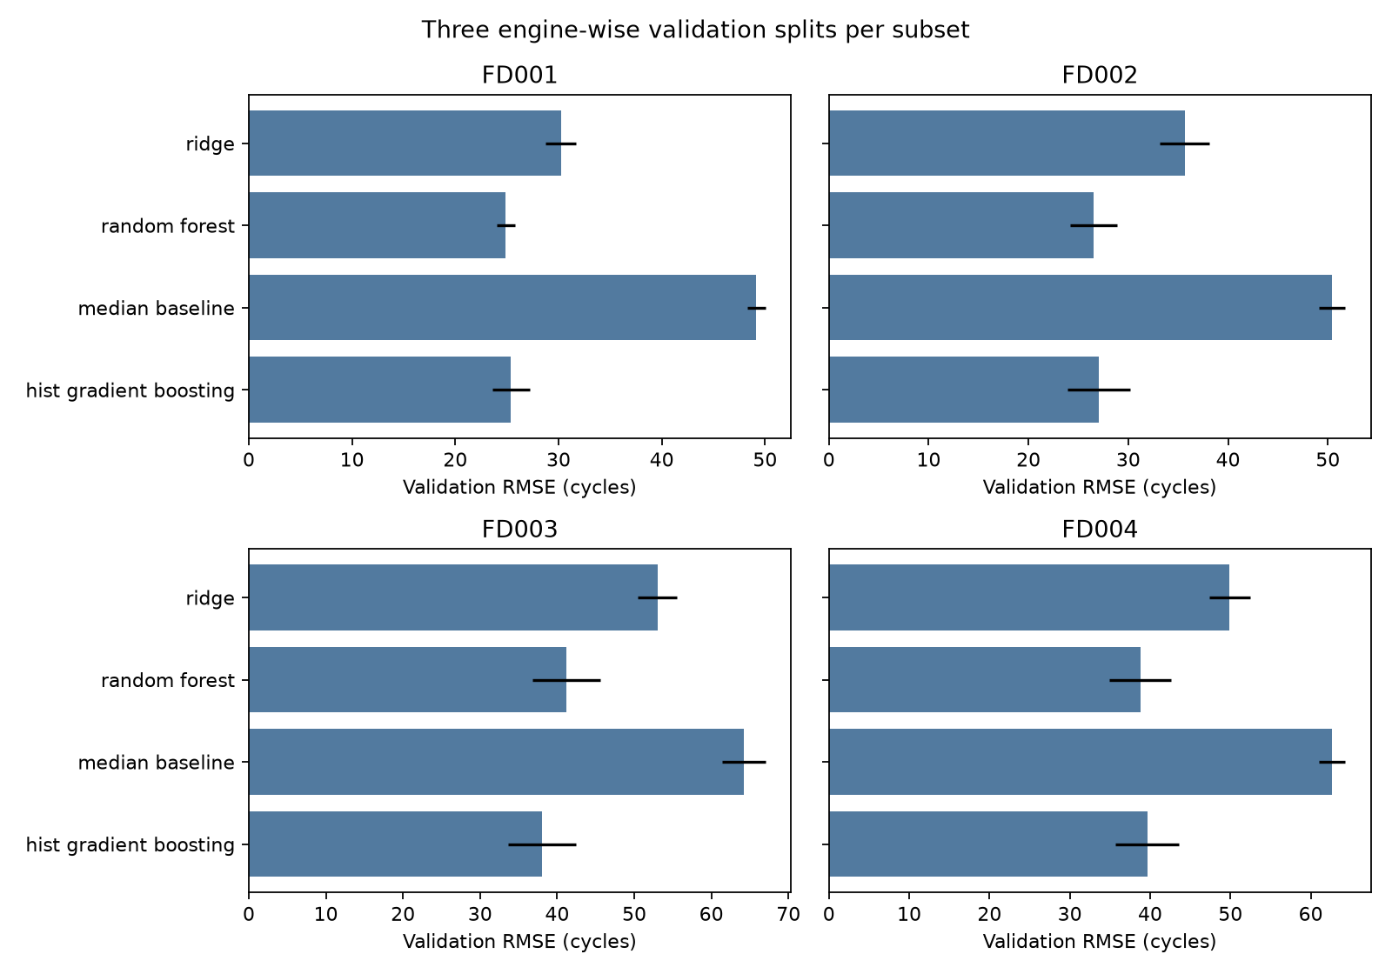
Mean validation RMSE across three engine-wise splits. Error bars show the standard deviation across repetitions. This post-hoc audit did not change official-test model selection.

